[Date]

Kyer Potts

30003389

Database Programming AT1.2

Art Database

1. Add the data to the “style” table from the list in the analysis section above. (save the SQL code to the word document):

INSERT INTO `style` (`Style`) VALUES

('Cubism'),

('Impressionism'),

('Mannerism'),

('Portrait'),

('Realism'),

('Renaissance'),

('Still-life'),

('Surrealism');

1. Add the following data to the “artist” table. Use the Insert command and save the SQL code to the word document. (save the SQL code to the word document):

INSERT INTO artist

VALUES

("August Renoir", "1841–1919"),

("Claude Monet", "1840-1926"),

("Jan Vermeer", "1632–1675"),

("Leonardo Da Vinci", "1452–1519"),

("Michelangelo", "1475–1564"),

("Pablo Picasso", "1881–1973"),

("Paul Cezanne", "1839–1906"),

("Raphael", "1483–1520"),

("Rembrandt", "1606–1669"),

("Salvador Dali", "1904-1989"),

("Vincent Van Gogh", "1853–1890");

1. . Next, complete the following table by adding data to the missing fields (Null) and then insert into the paintings table. Hint: use an internet search engine. (save the SQL code to the word document):

INSERT into painting(Title, Year, media, artistnamefk, stylefk)

values

("Bal du moulin de la Galette", 1876, "oil", "August Renoir", "Impressionism"),

("Doni Tondo (Doni Madonna)", 1507, "oil", "Michelangelo", "Mannerism"),

("Vase with Twelve Sunflowers", 1888, "oil", "Vincent Van Gogh", "Still-life"),

("Mona Lisa", 1503, "oil", "Leonardo Da Vinci", "Portrait"),

("The Potato Eaters", 1885, "oil", "Vincent Van Gogh", "Realism"),

("Sunrise", 1972, "oil", "Claude Monet", "Impressionism"),

("Loom with a Weaver", 1884, "oil", "Vincent Van Gogh", "Realism"),

("Last Supper", 1495, "fresco", "Leonardo Da Vinci", "Renaissance"),

("Nature morte au compotier", 1914, "oil", "Pablo Picasso", "Impressionism"),

("Houses of Parliament", 1899, "oil", "Claude Monet", "Renaissance"),

("Cafe Terrace at Night", 1888, "oil", "Vincent Van Gogh", "Impressionism"),

("At the Lapin Agile", 1905, "oil", "Pablo Picasso", "Impressionism"),

("The Persistence of Memory", 1580, "oil", "Salvador Dali", "Surrealism"),

("The Hallucinogenic Toreador", 1970, "oil", "Salvador Dali", "Surrealism"),

("Jaz de Bouffan", 1877, "fresco", "Paul Cezanne", "Impressionism");

1. 4. There is a mistake with the date of the ‘Jaz de Bouffan’ painting by Paul Cezanne, Use the update command to alter the date and enter the correct date into the date field. (save the SQL code to the word document):

UPDATE painting

Set year = 1876

WHERE title = "Jaz de Bouffan"

1. How many paintings are painted with oil?

SELECT COUNT(Media)

FROM `painting`

WHERE Media = "oil"

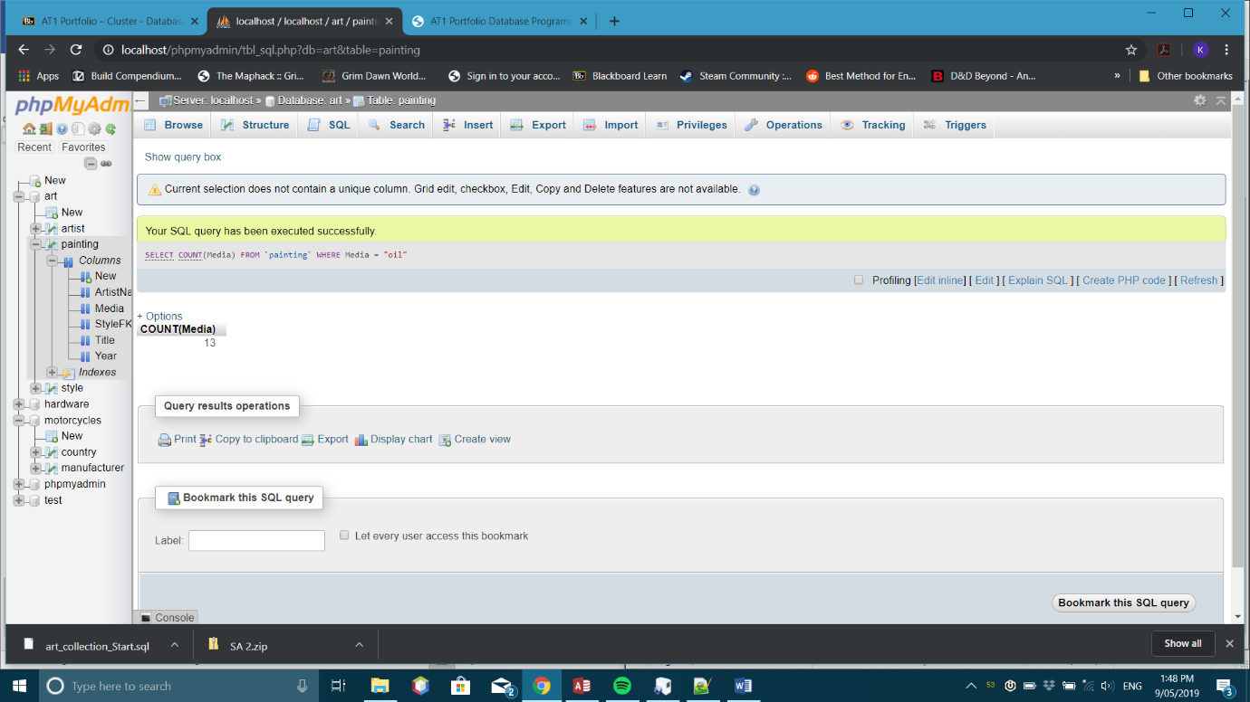

1. How many paintings are attributed to Vincent Van Gogh?

SELECT COUNT(artistnamefk)

FROM `painting`

WHERE artistnamefk = "Vincent Van Gogh"

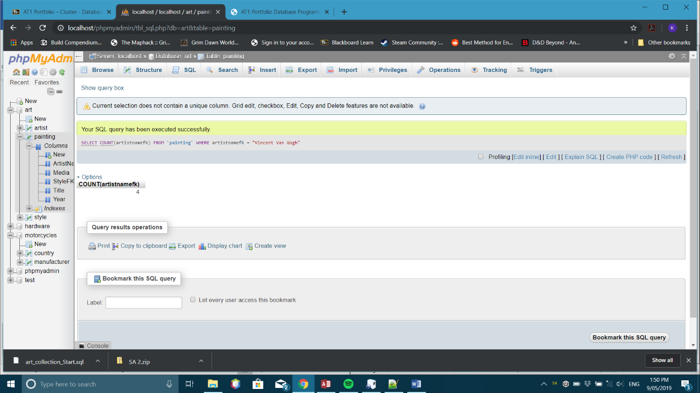

1. How many paintings are in the Impressionism style?

SELECT COUNT(stylefk)

FROM `painting`

WHERE stylefk = "Impressionism"

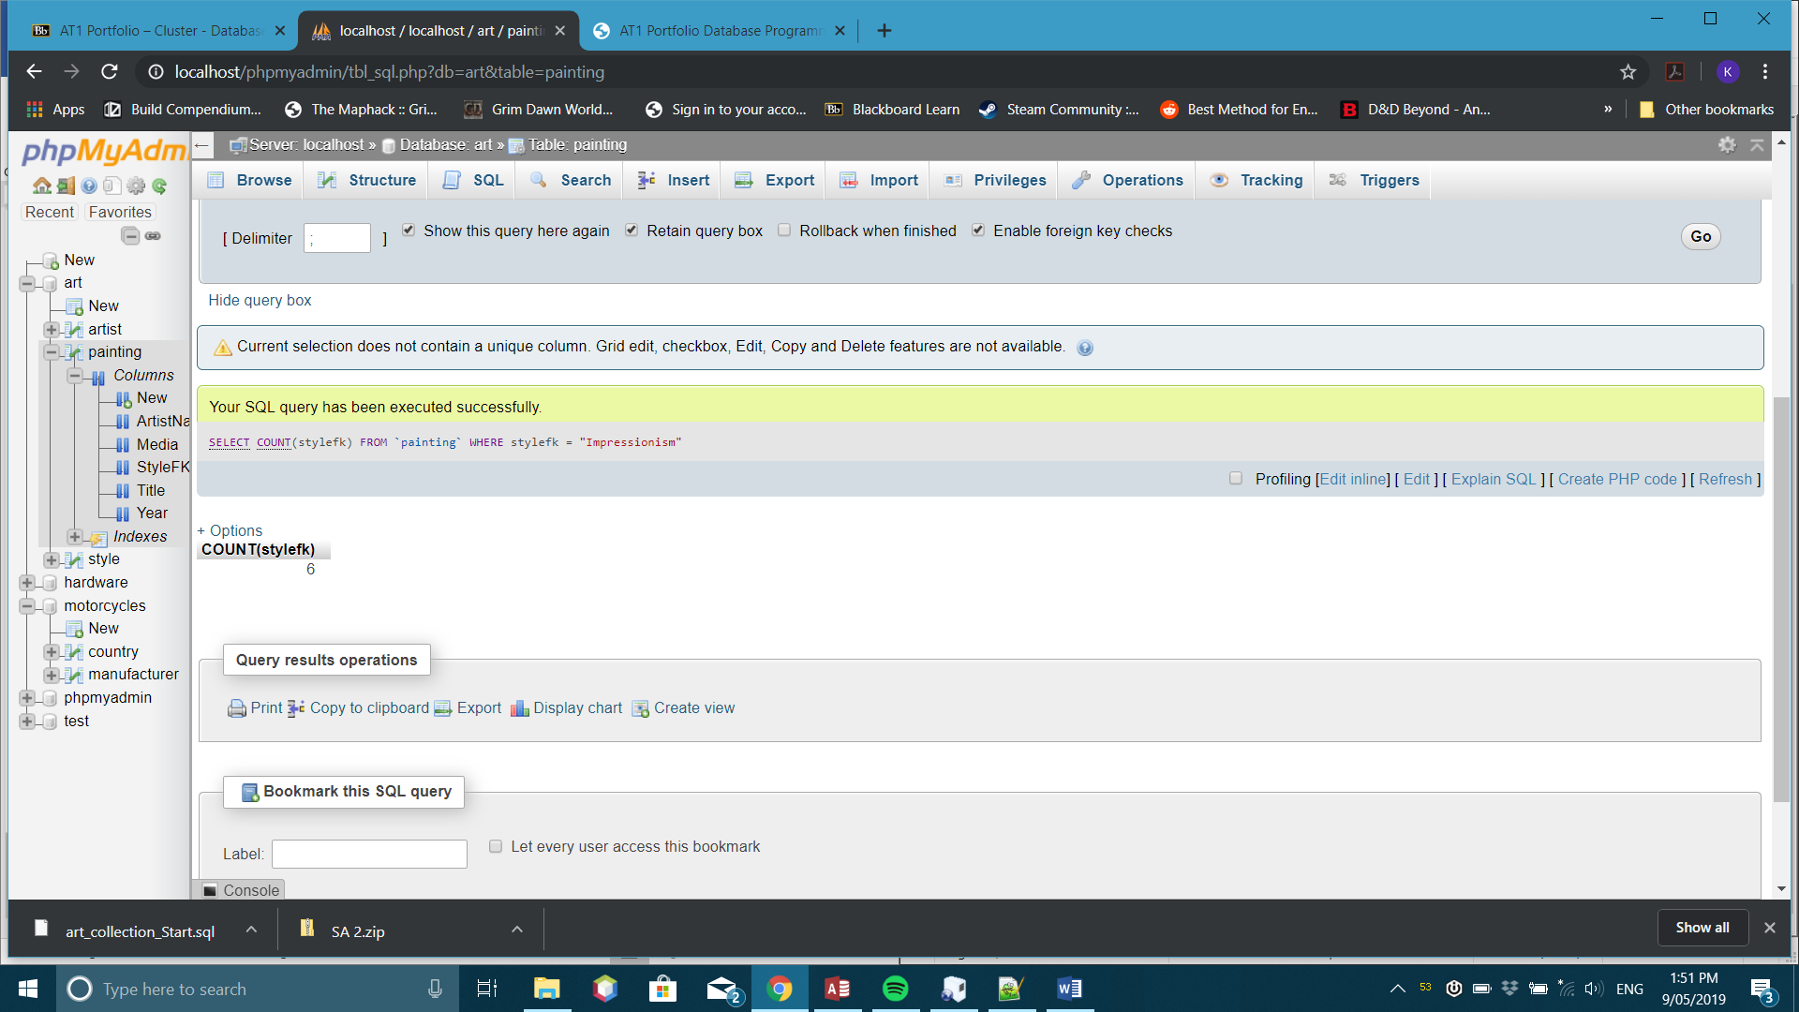

1. List all the paintings from the Impressionism style after 1900.

SELECT Title

From painting

WHERE year >= 1900 AND stylefk = "Impressionism"

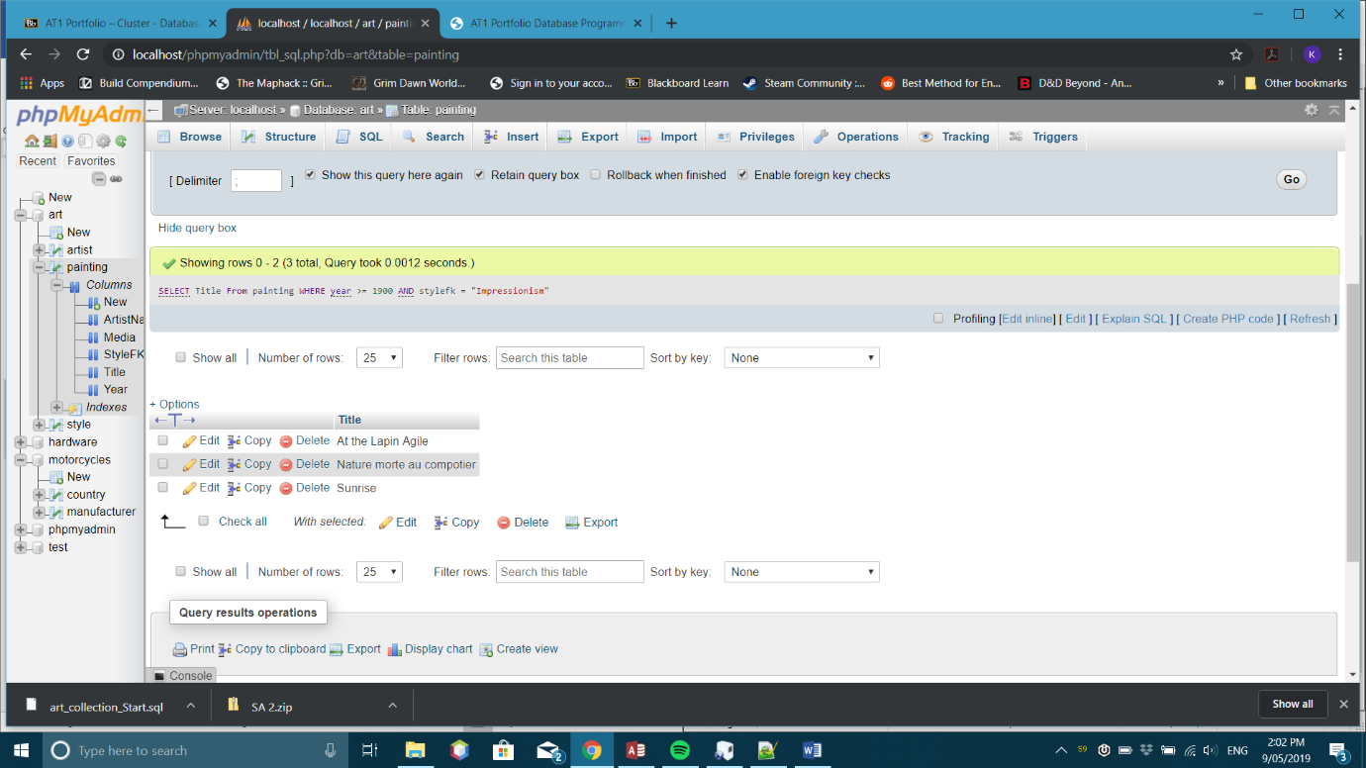

1. List all the paintings completed from 1801 to 1900.

SELECT title

FROM painting

WHERE year >= 1801 AND year <= 1900

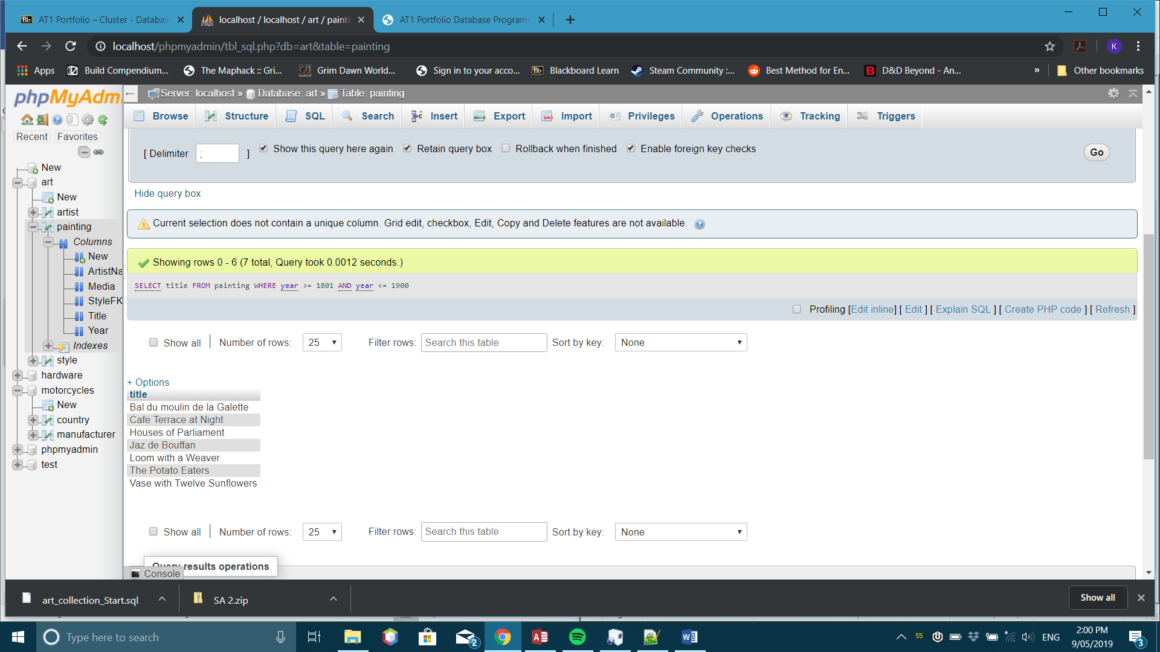

1. List the Artist Name and Style for all paintings completed before 1800.

SELECT artistnamefk, stylefk, year

FROM painting

WHERE year <= 1800

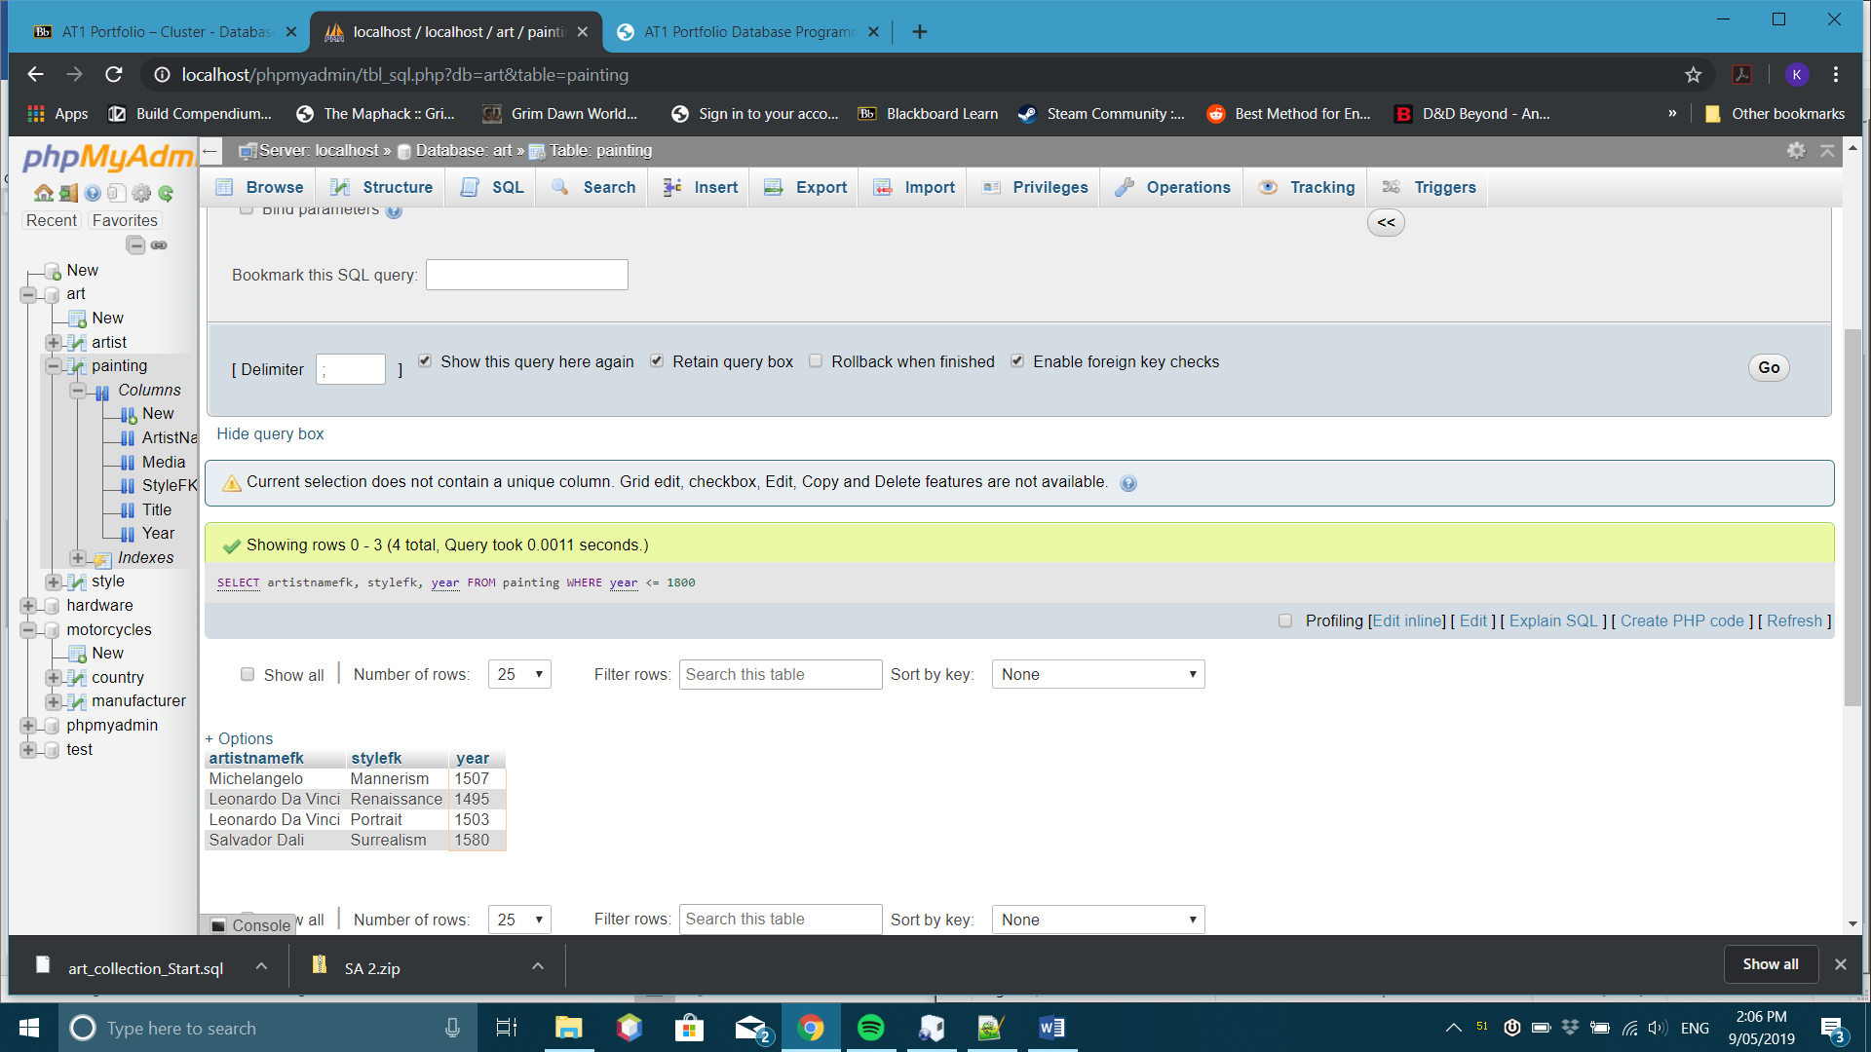

1. One of the paintings has been sold and you will need to remove this record. Use the delete command to remove the following item. (save the SQL code to the word document)

DELETE FROM painting

WHERE title = "Sunrise"

